2024 MDR-TB Drug Susceptibility Survey

Background
Since the introduction of new “second-line” agents for treatment of MDR- and XDR-TB, availability of agents such as Bedaquiline, Clofazimine, Delamanid and Linezolid has increased substantially. However, in order for clinicians to use these drugs effectively, susceptibility testing for these agents needs to be available. In 2019 RESIST-TB and the Union’s DR-TB Working Group surveyed their members about the availability of such testing and found that many areas were lacking this capacity. Therefore, in 2024 the survey was repeated, in hopes of demonstrating increases is such testing capacity.
Methods
In the fall of 2024 and the spring of 2025, a 14-question quantitative and qualitative survey (referred to as 2024 survey) was sent via email to all members of the IUATLD TB section and others. The purpose of the 2024 survey was to determine if progress had been made on the international availability of antibiotic susceptibility testing to second line drugs since the previous survey in 2019.Responses that were incomplete or missing were excluded. Responses for each question were assessed and/or reported as proportions (out of the total completed responses).
Results
The survey only received 25 responses, although all WHO regions were represented. The 2024 survey data are shown in comparison to the 2019 survey data through bar graphs. Most respondents reported having capacity for DST for Fluoroquinolones and Second-Line injectables (Figure 1). Compared to 2019, there was increased availabilty of testing from Bedaquiline (P=0.02), Clofazimine (P<0.01), Delamanid (P<0.001) and Linezolid (P=0.03), with no significant change for Fluoroquinolones and a modest decrease for Injectables (P=0.04). The greatest proportion of respondents reported sending samples for 1st line DST more than 10km and sending samples for 2nd line DST more than 50km (Figure 2). Finally, the greatest proportion of respondents shared an average turnaround time from sample collection to results for both 1st line DST and 2nd line DST greater than 21 days, respectively (Figure 3).

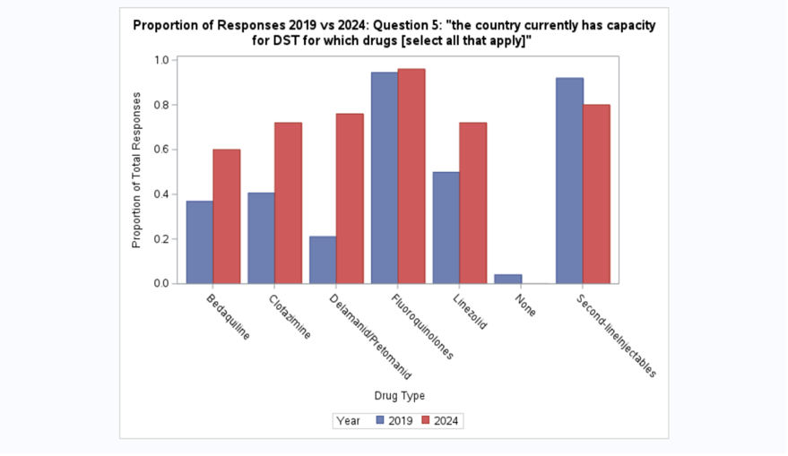
Figure 1: 2019 vs 2024 responses for Question 5: “The country currently has capacity for DST for which drugs [select all that apply]”.

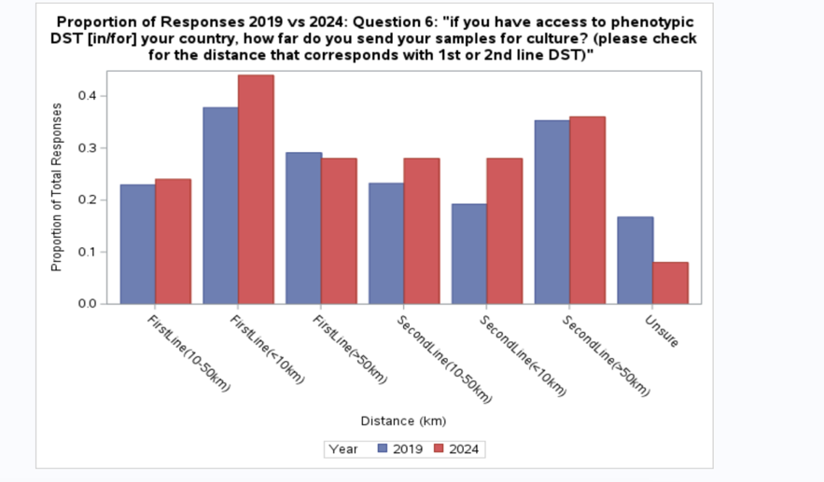
Figure 2: 2019 vs 2024 responses for Question 6: “If you have access to phenotypic DST [in/for] your country, how far do you send your samples for culture? (please check for the distance that corresponds with 1st or 2nd line DST)”.

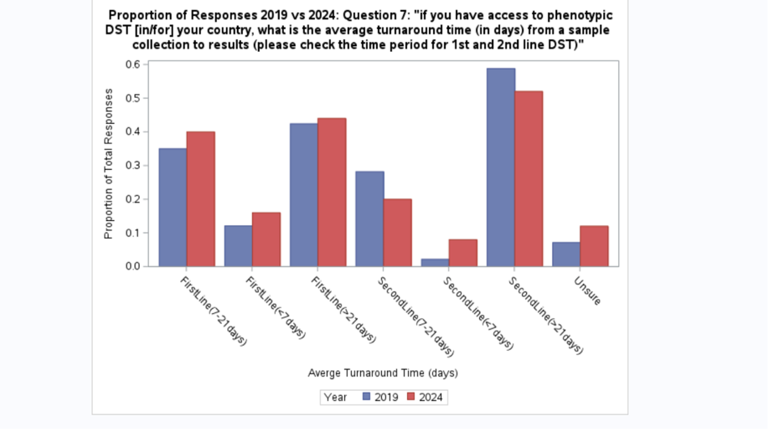
Figure 3: 2019 vs 2024 responses for Question 7: “If you have access to phenotypic DST [in/for] your country, what is the average turnaround time (in days) from a sample collection to results (please check the time period for 1st and 2nd line DST)”.

Conclusions
These results show that availability of susceptibility testing for the new agents increased, although not all areas were yet served. These results are limited by the low response rate, likely a result of the pullback of USAID causing potential respondents to focus on the reductions in TB services and limiting their time for responding to the survey.

